**Lab 4 - Design**

**Ensure you rename this document to your student number before uploading to git.**

**Task 1 - Other Products in your market**

|  |
| --- |
| <http://www.vehiclepartsdatabase.com/vehicles/> - This is an extremely large website which hosts a database of all types of vehicles, it ranges from cars to airplanes and is a perfect example of what our site should contain, the main page shows the images of each vehicle and allows the user to click through and select their chosen vehicle. It has a massive range of brands and their respective model variants all with their parts listed and many different branded variants of these parts. It also shows the user where the parts may also be purchased if they are needed.  <http://www.showmetheparts.com/catalog.html> - This is another similar page which hosts another large database of vehicle parts, more specifically this time it is based around cars, in this case however it actually hosts an in-webpage database which consists of a few drop down menus and allow the user to select each relevant option for their car such as year, engine, model, brand, variant and other options. It then runs a query and displays all the corresponding results for the criteria that they entered. |

**Task 2 - Potential customer (what do they want, make them as real as possible)**

Potential customers for such a site would include mainly car enthusiasts with interest in how their favourite cars are made, manufactured and where they can find parts for their cars. Similarly customers may also include day-to-day drivers who may just happen to be looking for a car part to repair their car and even a DIY guide to help them along the way. Mechanics may also fall into this bracket too for the same reason. More broadly other vehicle enthusiasts such as Aerospace and Nautical enthusiasts would also be attracted to such site.

Advertisers could be spread across many car, boat and plane forums across the internet where such enthusiasts gain in order to share, gain and such information about their favourite vehicles to one another, such forums include; airliners.net, pistonheads.com; thecarexpert.co.uk; carthrottle.co.uk; ybw.com and many more. These websites would be ideal for placing such a website’s advertising scheme on as it directly applies and relates the customers in question and would instantly grab their attention.

The sporting nature of such vehicles, specifically cars and boats would also create a huge opportunity for sponsorship of these vehicles in certain events. Such events would include car and boat racing events.

The ability to sponsor these events or even certain teams in these events would more than certainly spread the word of the site.

**Task 3 - Potential end-user (fictional biography, highlight why they would care about your product)**

End User: John Smith (Mechanic)

John Smith is an avid vintage car collector and general car enthusiast, he owns many vintage (and modern cars) he loves fixing cars and repairing them rather than taking them to a mechanic as he enjoys the challenge of fixing them himself.

With this, he requires a guide of how the car he is fixing is repaired. A website like this would be ideal for Mr Smith so he can understand how the car he wishes to repair is made so he can firstly diagnose the problem he is facing (if he is unsure) and/or fix the problem.

John may also just be genuinely interested in how his favourite cars are made and could use the website to feed his curiosity.

John could also use the website to identify flaws in his car with the way they’re made and it could also allow him to change out existing parts for potentially safer or higher performance parts. This being quite an important use for vehicles of a more vintage status whereby safety standards or performance rating may be significantly lower than that of their modern day replacement.

**Task 4 - What will attract end users (reference existing products)**

In order to attract customers a straight forward and well laid out UI is crucial. By nature, the complicated make up of vehicles is always very confusing to any individual and it is absolutely vital that the site is understandable to any user and not just enthusiasts, this means that the language used must be simple but yet accurate when describing parts and how they work, specialist terms should be avoided and where needed they should be explained to the novice users. The vehicles sections must be broken down into many subcomponents and there must be easy navigation so any user can immediately tell where they are on the site and also how they would find where they are looking for. Any guide or information also provided on the site must also follow a simple and easy layout. Similar to that of blueprints for a product, whereby every component is noted and distinguishable from the rest. Lots of bright colours should be avoided where possible to avoid clashing colours and unattractive colour schemes. Such examples of ideal sites include;

UsedCarsNI

AutoTrader

YachtWorld

UK.Boats

**Task 5 - Suggest essential & nice-to-have features (make them emotional not technical)**

For the navigation of the website it is imperative that the search functionality uses a dropdown menu with every possible choice available to the user, search bars are far too complicated by nature and by already giving the user a list of options it restricts the user from entering in a term that either may be incorrect or misinterpreted, i.e breaks instead of brakes.

The dropdown menu concept is present on all the example sites, all of which are the top sites for their respective markets. The dropdown menu allows for easy navigation as it allows the user to precisely select from the options they want and pick the exact vehicle they are after.

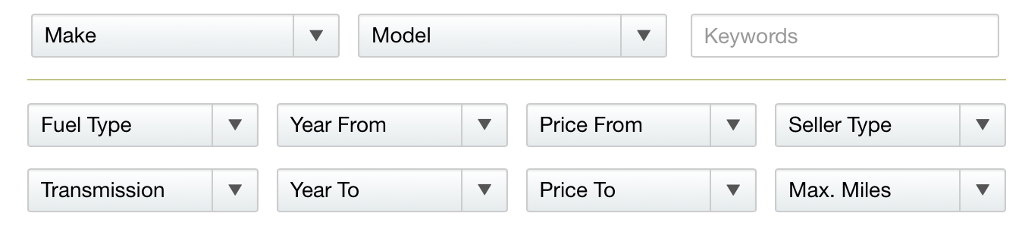

Nice to have Features

These could include the ability to view the most frequently accessed guides and vehicles on the site and possibly a rating system that would allow users to vote for which guides they find the most useful, the more common brands of vehicles such as Boeing, Volkswagen, Audi, Volvo, Ferrari, Vauxhall, Mini, BMW etc could also be placed on these lists to help the majority of users find their brand of vehicle more quickly allowing for quicker retrieval of these guides and videos.

A user section could also be implemented which would allow for forums and discussions of certain guides and also user submitted guides on how certain vehicles are made. This use of a user driven community would also help advertise and build upon the website.

**Task 6 - Use case (A story of one of your end users first experience and feelings interacting with your website)**

John’s vintage Mini breaks down one day and after seeing the site advertised on other popular car forums he decides to visit the site, upon entering he is greeted by the home page which displays a short bit of information explaining the site and prompted by the links to the other main pages of the site, this promptly directs him through the site asking him to choose a vehicle section, he notices the websites pages all follow an easy to read and consistent layout which allows him to more easily navigate throughout the site and onto the other pages for finding his car. He then selects car as his Mini is a car. He then enters in the sub-information such as the Brand, Model, Year, Engine and other various information about his car. He is then directed to a guide which shows how this particular car in question is made and works. He uses this information to figure out what the problem is with his car. He is instantly very pleased by the videos provided making the understanding for him much easier than by just having to read piles of text. He watches a few embedded YouTube videos and identifies exactly what his issue is. He then decides to create an account with the website through the easily accessed sign and login link at the top of his page.

**Task 7**

Home Page – Main index page of site where the site will default to when opened. This will display all links available to each page on the site.

Search Page - Page that will facilitate the search functionality of the site to best find the most appropriate result for the user.

Add/Edit Page – Page that will allow the user to add their own information and even edit a page in a Wikipedia style of way so that they can contribute their own information to them.\

Login and Signup Page – Page allowing user to login and signup so that they can access their account.